Lab 6: DHCP Configuration of VLANs and Inter–VLAN Routing Using Router–on–a–Stick
Objective
To design a switched network using three Layer 2 switches, segment it into two Virtual LANs (VLANs) using access and trunk ports, and to configure inter-VLAN routing on a router using the router-on-a-stick method with sub-interfaces and IEEE 802.1Q encapsulation, so that devices on the same VLAN can communicate across switches while devices on different VLANs remain isolated unless routed through the router.

Theory
1. VLAN (Virtual LAN)
A VLAN (Virtual Local Area Network) is a term for splitting one physical network into several logical networks. Devices wired to the same physical switch can be grouped into different logical networks based on department, role, or purpose, with each VLAN forming its own broadcast domain.
For instance, an organization might set up individual VLANs for its Accounts, IT, and Management teams. Devices placed in one VLAN cannot usually talk directly to devices in a different VLAN unless a routing path is added. This grouping keeps the network organized and cuts down on unnecessary broadcast traffic.
2. Access Port and Trunk Port
An Access Port is a switch interface dedicated to a single VLAN. It typically connects end devices such as computers and printers, and the device plugged into it never needs to know VLANs are in use.
A Trunk Port is a switch interface capable of carrying traffic for multiple VLANs at once. It is mainly used to link network devices such as switches and routers, and VLAN tags are added to the traffic so the receiving device can tell which VLAN each frame belongs to.
Access Port | Trunk Port
Carries traffic for one VLAN | Carries traffic for multiple VLANs
Usually connects end devices | Usually connects switches or routers
VLAN information is generally not carried to the end device | VLAN information is maintained between network devices
3. Inter-VLAN Routing
Inter-VLAN Routing is what allows devices sitting in different VLANs to talk to one another. Because each VLAN functions as its own network, devices in separate VLANs cannot reach each other directly without some form of Layer 3 routing.
For example, a computer in the IT VLAN cannot talk to a computer in the Accounts VLAN unless a router or Layer 3 switch traffic forwards between the two. Inter-VLAN routing therefore becomes necessary whenever devices in different departments or segments need to communicate.
4. Router-on-a-Stick
Router-on-a-Stick is a technique for handling Inter-VLAN Routing through a single physical router interface, which connects to a switch over a trunk link.
Within that link, the router creates distinct logical interfaces, known as sub-interfaces, one for each VLAN. Each sub-interface is tied to a specific VLAN and holds the IP address that serves as its gateway.
Whenever a device needs to reach another VLAN, its traffic travels up the trunk link to the router first. The router then figures out which VLAN the traffic is headed for and sends it back down the same physical link. In this way, several VLANs can exchange traffic even though the router only uses a single physical interface.
In this lab, the Router-on-a-Stick configuration also works together with DHCP to automatically hand out IP addresses to devices across the different VLANs.

Components Required
- Cisco Packet Tracer
- 1 Router (2901)
- 3 Switches (2960)
- PCs/Laptops
- Copper Straight-Through Cables
- Copper Cross-Over Cables

Procedure:
- Network Topology
Steps:
- Launch Cisco Packet Tracer.
- Drag a router, three switches, and the end devices onto the workspace.
- Make the following connections:
  - Wire each PC and laptop to its corresponding switch.
  - Link the switches to the router with Copper Straight-Through cables.
  - Link the two routers to each other.
- Record the IP addresses required for the setup.
Output:
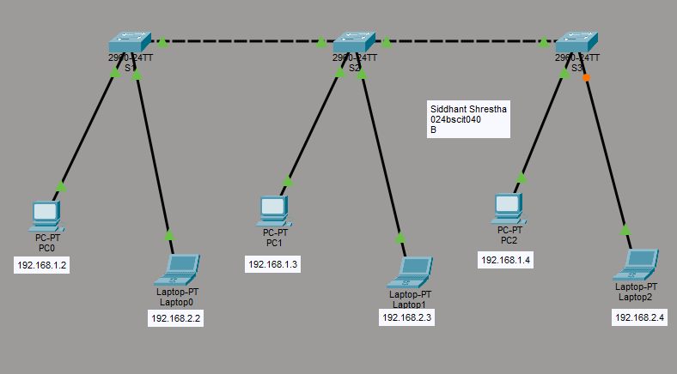

- Static IP Address Assignment
Steps:
- Give each end device an IP address that matches the VLAN it belongs to.
- VLAN 10 devices sit on the 192.168.1.0/24 network, while VLAN 20 devices are placed on the 192.168.2.0/24 network.
- Until Inter-VLAN Routing is set up, devices in different VLANs cannot reach each other, as the output below demonstrates.
Output:
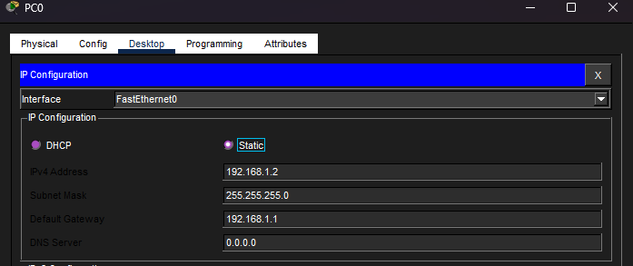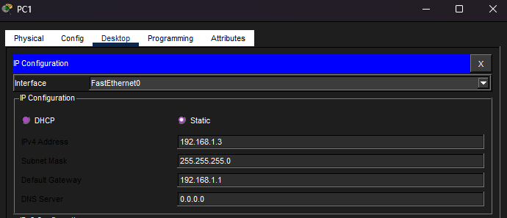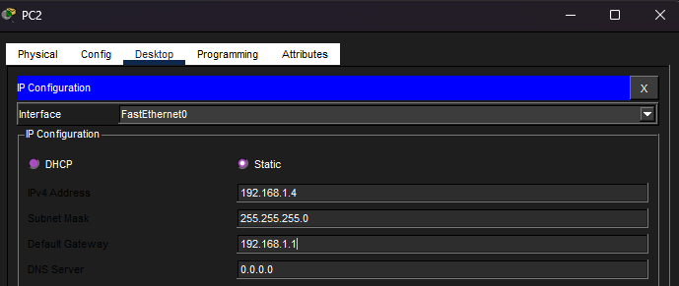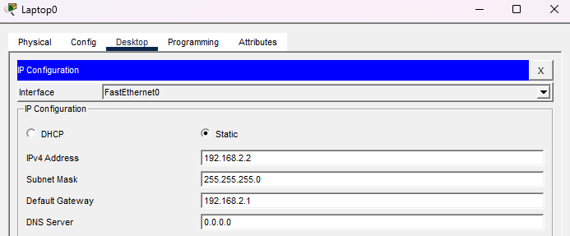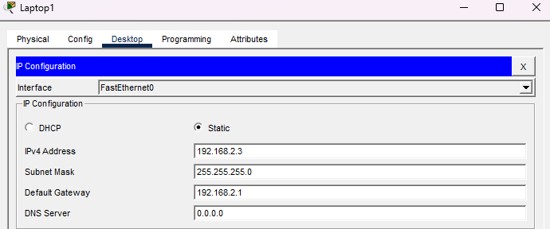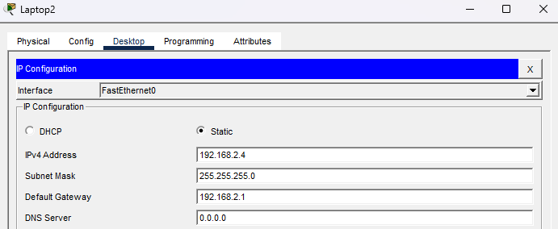

IP Addressing Scheme
Device & Interface | Switch & Interface | IP Address | Default Gateway | VLAN
PC0 – Fa0/1 | Siddhant_S1 – G0/1 | 192.168.1.2 | 192.168.1.1 | VLAN 10
PC1 – Fa0/1 | Siddhant_S2 – G0/1 | 192.168.1.3 | 192.168.1.1 | VLAN 10
PC2 – Fa0/1 | Siddhant_S3 – G0/2 | 192.168.1.4 | 192.168.1.1 | VLAN 10
Laptop0 – Fa0/2 | Siddhant_S1 – G0/1 | 192.168.2.2 | 192.168.2.1 | VLAN 20
Laptop1 – Fa0/2 | Siddhant_S2 – G0/2 | 192.168.2.3 | 192.168.2.1 | VLAN 20
Laptop2 – Fa0/2 | Siddhant_S3 – G0/2 | 192.168.2.4 | 192.168.2.1 | VLAN 20
Network and VLAN Scheme
Network | Network Address | Subnet Mask | VLAN | Gateway | Port
Admin Network | 192.168.1.0/24 | 255.255.255.0 | VLAN 10 | 192.168.1.1 | Fa0/1
IT Network | 192.168.2.0/24 | 255.255.255.0 | VLAN 20 | 192.168.2.1 | Fa0/2
- Pinging from VLAN 10 to VLAN 20
PC0 to Laptop0
Output:
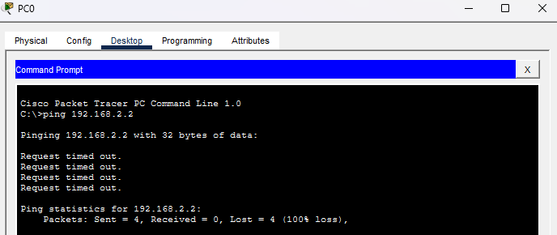

- VLAN Creation
Steps:
- Access the CLI of the first switch within Cisco Packet Tracer.
- Move into the switch's global configuration mode.
- Set up VLAN 10 and give it a descriptive name, for example Admin.
- Set up VLAN 20 and give it a descriptive name, for example IT.
- Place the ports that connect to the PCs into VLAN 10.
- Place the ports that connect to the laptops into VLAN 20.
- Carry out the same VLAN creation and port-assignment steps on the remaining switches.
- Confirm that each port has been placed in the correct VLAN.
- Review the VLAN status on every switch to make sure that:
  - VLAN 10 holds the PC ports.
  - VLAN 20 holds the laptop ports.
- At this point, devices within the same VLAN should already be able to reach one another, but traffic between VLAN 10 and VLAN 20 will keep failing until Inter-VLAN Routing has been configured.
CLI for VLAN creation:
Switch>en
Switch#conf t
Enter configuration commands, one per line. End with CNTL/Z.
Switch(config)#hostname Siddhant_S1
Siddhant_S1(config)#vlan 10
Siddhant_S1(config-vlan)#name Admin
Siddhant_S1(config-vlan)#exit
Siddhant_S1(config)#vlan 20
Siddhant_S1(config-vlan)#name IT
Siddhant_S1(config-vlan)#exit
Siddhant_S1(config)#exit

Output:
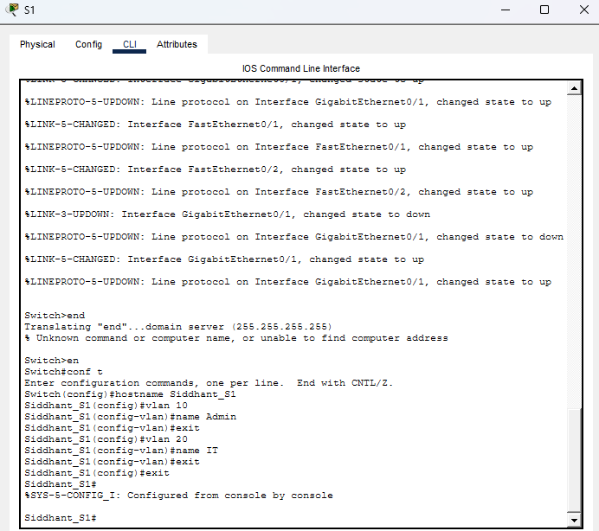
CLI for verification
Siddhant_S1#show vlan brief
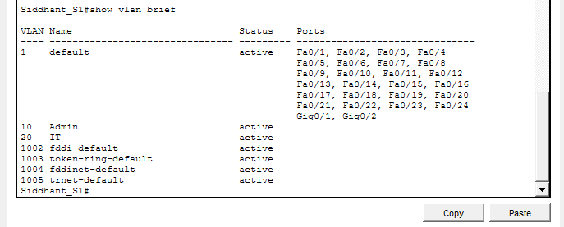
Output:
- Port Assignment
Steps:
- Set up VLAN 10 (Admin) and VLAN 20 (IT) on each of the three switches.
- On every switch, make Fa0/1 an access port for VLAN 10 and Fa0/2 an access port for VLAN 20.
- Turn the necessary GigabitEthernet ports into trunk ports so they can carry traffic for multiple VLANs.
- Check the VLAN status table to confirm the right ports have been assigned to VLAN 10 and VLAN 20.
CLI:
Siddhant_S1# conf t
Siddhant_S1(config)#interface fastEthernet 0/1
Siddhant_S1(config-if)#switchport mode access
Siddhant_S1(config-if)#switchport access vlan 10
Siddhant_S1(config-if)# exit
Siddhant_S1(config)#interface f0/2
Siddhant_S1(config-if)#switchport mode access
Siddhant_S1(config-if)#switchport access vlan 20
Siddhant_S1(config-if)#exit

Output:
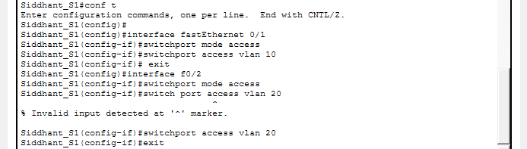

Siddhant_S1(config)#interface g0/1
Siddhant_S1(config-if)#switchport mode trunk
Siddhant_S1(config-if)#
%LINEPROTO-5-UPDOWN: Line protocol on Interface GigabitEthernet0/1, changed state to down
%LINEPROTO-5-UPDOWN: Line protocol on Interface GigabitEthernet0/1, changed state to up
Siddhant_S1(config-if)#exit
Siddhant_S1(config)#interface g0/2
Siddhant_S1(config-if)#switchport mode trunk
Siddhant_S1(config-if)#exit
Siddhant_S1(config)#exit
Siddhant_S1#
%SYS-5-CONFIG_I: Configured from console by console
Siddhant_S1#wr

Output:
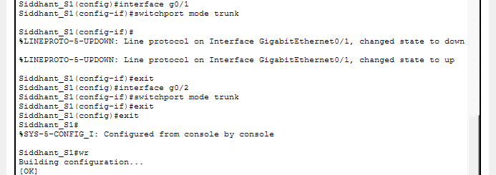

Siddhant_S1#show vlan brief
Output:
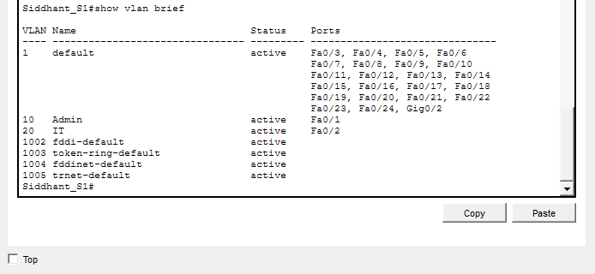

- Apply this same configuration across Siddhant_S1, Siddhant_S2 and Siddhant_S3.
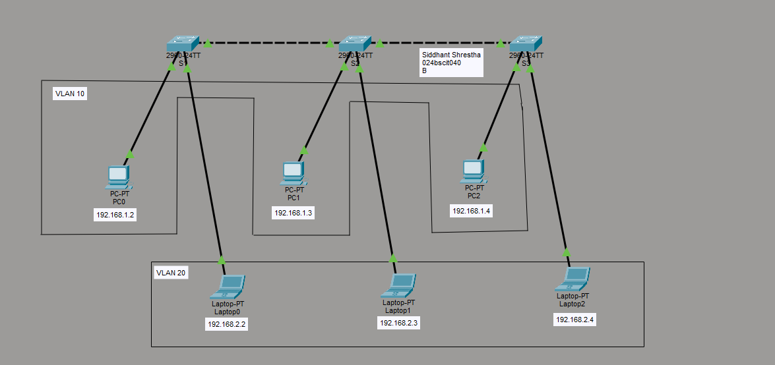

Testing whether the endpoints within a VLAN can reach each other
- Pinging from PC0 (192.168.1.2) to PC1 (192.168.1.3).

Output:
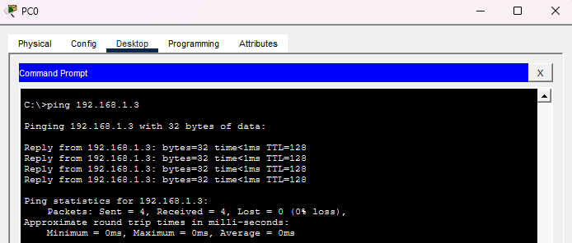

6. Configuration of Inter-VLAN Routing Using Router-on-a-Stick
Steps:
- Bring up the router's GigabitEthernet 0/0 interface, then create the G0/0.10 and G0/0.20 subinterfaces for VLAN 10 and VLAN 20.
- Give VLAN 10 the gateway address 192.168.1.1/24 and VLAN 20 the gateway address 192.168.2.1/24.
- Apply 802.1Q encapsulation on the subinterfaces so VLAN 10 and VLAN 20 traffic can be correctly identified.
- Save the router's configuration and confirm connectivity between the VLANs by pinging between devices in different VLANs.

CLI:
Router>en
Router#conf t
Enter configuration commands, one per line. End with CNTL/Z.
Router(config)#hostname Siddhant_R
Siddhant_R(config)#interface g0/0
Siddhant_R(config-if)#no shutdown

Siddhant_R(config-if)#
%LINK-5-CHANGED: Interface GigabitEthernet0/0, changed state to up

%LINEPROTO-5-UPDOWN: Line protocol on Interface GigabitEthernet0/0, changed state to up

Siddhant_R(config-if)#interface g0/0.10
Siddhant_R(config-subif)#
%LINK-3-UPDOWN: Interface GigabitEthernet0/0.10, changed state to down

%LINEPROTO-5-UPDOWN: Line protocol on Interface GigabitEthernet0/0.10, changed state to up

Siddhant_R(config-subif)#encapsulation dot1Q 10
Siddhant_R(config-subif)#ip address 192.168.1.1 255.255.255.0
Siddhant_R(config-subif)#exit
Siddhant_R(config)#interface g0/0.20
Siddhant_R(config-subif)#
%LINK-3-UPDOWN: Interface GigabitEthernet0/0.20, changed state to down

%LINEPROTO-5-UPDOWN: Line protocol on Interface GigabitEthernet0/0.20, changed state to up

Siddhant_R(config-subif)#encapsulation dot1Q 20
Siddhant_R(config-subif)#ip address 192.168.2.1 255.255.255.0
Siddhant_R(config-subif)#exit
Siddhant_R(config)#exit
Siddhant_R#
%SYS-5-CONFIG_I: Configured from console by console

Siddhant_R#wr
Output:
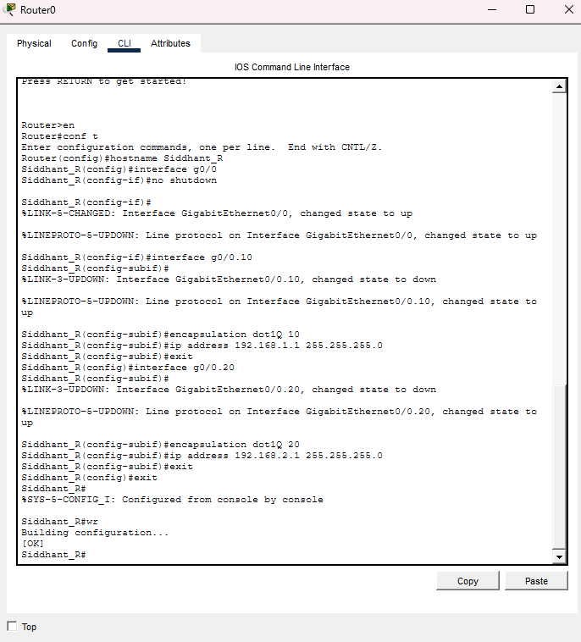

IP Addressing Scheme
Device | Interface | IP Address | Connected To | Network
Router | G0/0.10 | 192.168.1.1 | VLAN 10 | 192.168.1.0/24
Router | G0/0.20 | 192.168.2.1 | VLAN 20 | 192.168.2.0/24

Output:
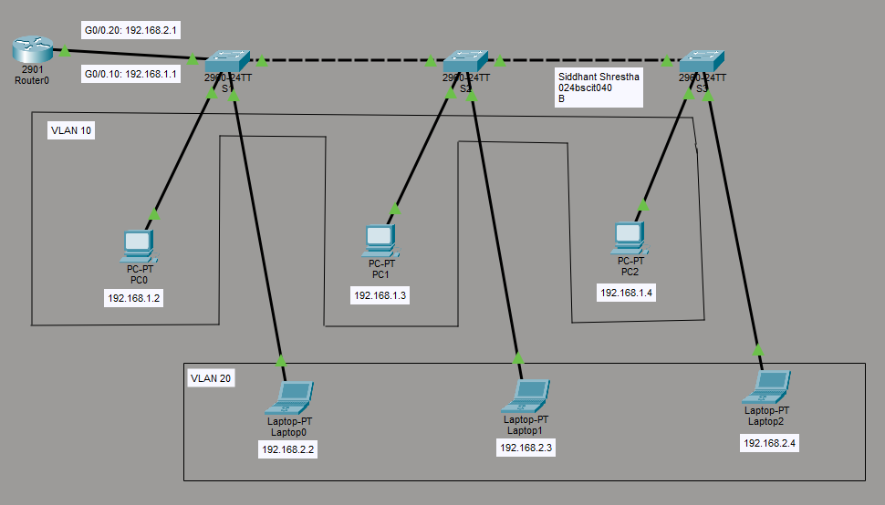

Testing whether the VLANS can reach each other
- Pinging from PC0 (192.168.1.2) to Laptop1 (192.168.2.3)
Output:
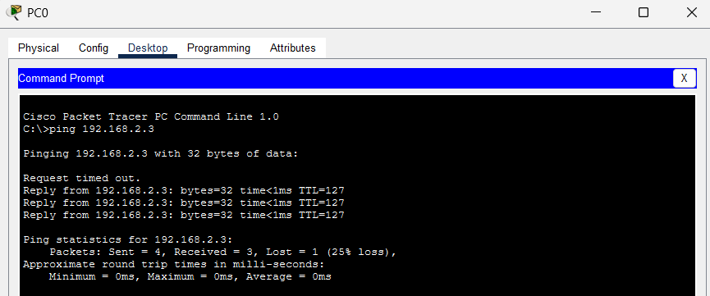
- Pinging from PC0 (192.168.1.2) to Laptop2 (192.168.2.4)
Output:
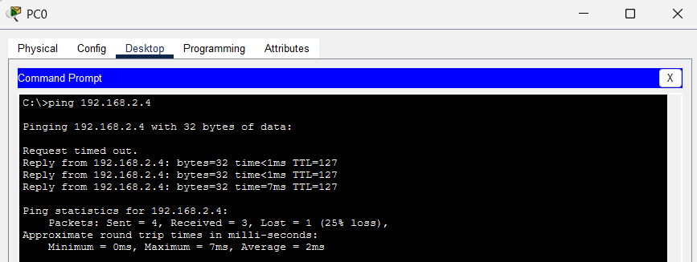

Conclusion
VLANs break a single physical network into multiple broadcast domains, which strengthens organization, security, and performance. Even so, devices sitting in different VLANs still need Layer 3 routing before they can communicate. The Router-on-a-Stick approach turned out to be an efficient fix, enabling inter-VLAN communication through one physical router interface split into logical subinterfaces. Taken together, VLANs paired with proper routing produce a network that is both scalable and well organized, even though it demands careful setup and troubleshooting.

